

Practices for Secure Software Report

Table of Contents
Document Revision History 3
Client 3
Instructions 3
Developer 4
1. Algorithm Cipher 4
2. Certificate Generation 4
3. Deploy Cipher 4
4. Secure Communications 4
5. Secondary Testing 4
6. Functional Testing 4
7. Summary 4
8. Industry Standard Best Practices 4

Document Revision History

Version | Date | Author | Comments
1.0 | 8/11/2026 | Jacob Griggs

Client



Developer
Jacob Griggs

Algorithm Cipher

Artemis Financial required a secure method for verifying the integrity of data transmitted through its web application. To address this requirement, SHA-256 was selected as the cryptographic hash algorithm used to generate checksum values. SHA-256 is part of the SHA-2 family of hashing algorithms and is widely recognized as an industry-standard solution for data integrity verification.
SHA-256 produces a fixed 256-bit hash value represented as a 64-character hexadecimal string. The algorithm is deterministic, meaning the same input always produces the same output, while even a minor modification to the original data results in a completely different hash. This characteristic makes SHA-256 highly effective for detecting unauthorized modifications to transmitted information.
While SHA-256 is a hashing algorithm rather than an encryption algorithm, it works alongside encryption technologies used in secure communications. Modern security implementations commonly use symmetric encryption algorithms such as AES-256 for data encryption and asymmetric algorithms such as RSA for certificate-based authentication and secure key exchange. Random number generation is an important component of these systems because it helps create secure cryptographic keys and certificates.
Historically, organizations relied on algorithms such as DES, 3DES, MD5, and SHA-1. However, many of these algorithms have become outdated because of weaknesses discovered through advances in computing power and cryptographic research. Today, modern security standards favor stronger algorithms such as SHA-256, SHA-384, SHA-512, AES-256, RSA-2048, and Elliptic Curve Cryptography (ECC). SHA-256 was selected because it provides strong collision resistance, excellent performance, and broad industry adoption for integrity verification.

Certificate Generation
A self-signed SSL certificate was successfully generated using Java Keytool and imported into the Artemis Financial application. The certificate enables encrypted HTTPS communication between users and the application server.
The generated certificate was exported as a CER file and verified to ensure proper creation. The certificate includes identifying information, a public key, and a validity period that supports secure communication through SSL/TLS protocols.

[Insert screenshots here.]

Deploy Cipher
The application was refactored to implement SHA-256 checksum generation. The checksum feature produces a unique hash value for a given input string and allows users to verify that transmitted information has not been altered.
The deployed cipher demonstrates the following functions:
- Accepts an input string.
- Generates a SHA-256 hash.
- Displays the resulting checksum.
- Allows integrity verification through hash comparison.
The checksum functionality successfully validates data integrity and supports secure communication requirements established by Artemis Financial.
[Insert screenshots here.]

Secure Communications
The application was confirmed to support HTTPS communications instead of HTTP. SSL/TLS was enabled within the application properties file by referencing the generated keystore and certificate. The browser displayed a secure connection, verifying that encrypted communication between the client and server was functioning correctly. This implementation improves confidentiality and protects information transmitted across the network.
[Insert screenshots here.]

Secondary Testing
OWASP Dependency-Check version 12.1.0 was integrated into the Maven build process and executed against the Artemis Financial application. The scan successfully updated vulnerability databases, analyzed application dependencies, and generated a dependency-report file. The scan identified several vulnerabilities within existing third-party framework dependencies, including Spring Boot, Spring Framework, Jackson Databind, Hibernate Validator, SnakeYAML, and Tomcat libraries. These vulnerabilities were inherited from the original project dependencies and were not introduced by the newly implemented HTTPS and SHA-256 security enhancements. During analysis, the Sonatype OSS Index Analyzer returned HTTP 401 Unauthorized authentication warnings from an external service. Despite these warnings, Dependency-Check completed vulnerability analysis and generated a report for review.

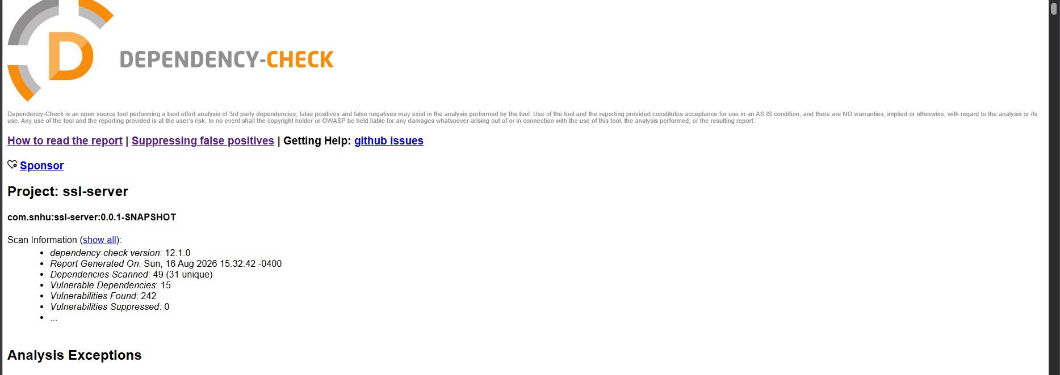

Functional Testing
Functional testing was performed through manual review, application compilation, and execution testing. The application compiled successfully and all tests completed without errors. Results showed:
- Tests run: 1
- Failures: 0
- Errors: 0
- Skipped: 0
The checksum functionality operated correctly, HTTPS configuration loaded successfully, and no syntax or logical errors were found within the refactored code.

Summary

The Artemis Financial application was successfully refactored to improve communication security and data integrity. Multiple layers of security were implemented, including SHA-256 checksum generation, SSL/TLS encryption, HTTPS communication, certificate management, vulnerability scanning, and manual code review.
The vulnerability assessment process addressed several critical security areas:
- Cryptography
- Data integrity
- Secure communications
- Certificate management
- Application configuration
- Dependency management
- Secure software testing
Security was enhanced through a layered defense approach. First, SHA-256 checksum generation was implemented to verify data integrity. Next, SSL/TLS encryption and HTTPS communication were enabled to protect data during transmission. Finally, Dependency-Check and functional testing were performed to validate that no additional vulnerabilities were introduced.
These enhancements help protect sensitive financial information and support the organization's objective of maintaining secure communications throughout the application lifecycle.

Industry Standard Best Practices

Industry-standard secure coding practices were applied throughout this project to strengthen the application's security posture. Strong cryptographic technologies including SHA-256 and SSL/TLS were implemented instead of relying on outdated algorithms. Secure configuration practices were followed, and automated vulnerability assessment tools were used to identify potential weaknesses within application dependencies.
Existing security was maintained by performing code reviews, testing application functionality after modifications, validating the HTTPS configuration, and reviewing dependency analysis reports for potential vulnerabilities. These activities helped ensure that newly added security controls did not negatively affect application behavior.
Applying industry-standard best practices provides significant value to Artemis Financial by protecting sensitive customer information, reducing the likelihood of security incidents, supporting regulatory compliance efforts, increasing customer trust, and reducing long-term remediation costs. Security-focused development practices help establish a stronger overall cybersecurity posture and contribute to the continued reliability and success of the organization.

